Becky Matthews-Pease
IST 652: Scripting for Data Analysis
Homework #2

This data set pull in tweets and users using the hashtag “DisabilityTwitter” between November 17, 2020 and shortly after midnight November 22, 2020. After much difficulty in the json file not formatting correctly while using Tweepy, another webscraper designed to work specifically with twitter was used. Packages used were pandas, wordcloud, as well as TextBlob, advertools, and Twython.

The output file of the twitter scrapper returned a wealth of information, but much of it not usable, such as blank columns, the color of the user’s background, profile photo, etc. These superfluous columns were deleted, the format of column names noted, and then the dataset reloaded into Python.

This program sets out to gather tweets and return them in the form of a json file for some data cleaning before pulling the newly cleaned data back in for analysis. It then sets out to answer two questions: What are some of the traits of the #DisabilityTwitter hashtag, such as users with the most followers, the most tweets, and when tweets are made? And what is being said in this tag? Is the overall tone positive, neutral, or negative, and what sorts of words are most commonly used?

What are Some of the Traits of the #DisabilityTwitter Tag?

Users in #DisabilityTwitter Tag with the Most Followers:
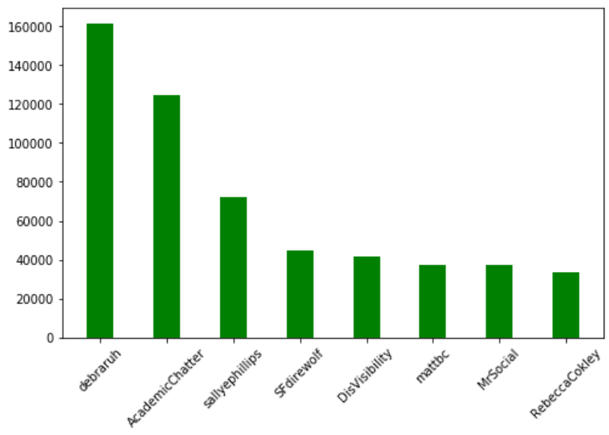

user_screen_name user_followers_count
549 debraruh 161572
8 AcademicChatter 124777
611 sallyephillips 72451
627 SFdirewolf 44957
130 DisVisibility 41889
491 mattbc 37467
826 MrSocial 37280
229 RebeccaCokley 33526

Users in #DisabilityTwitter Tag with the Most Tweets in the Tag:
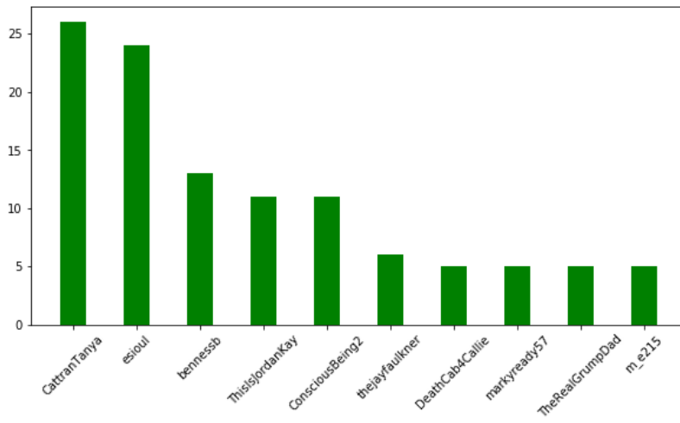
For this particular time frame, there are no overlaps between within the tag with the most followers and the users with the highest number of tweets in the tag.

How Do Users Make Tweets from Twitter?:
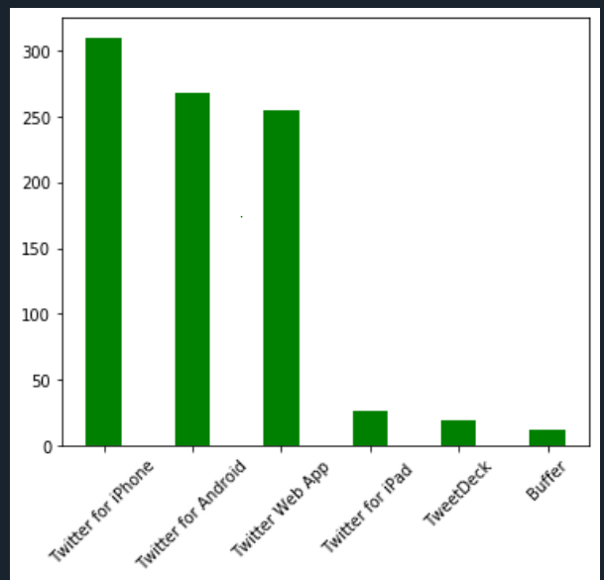

Users within the tag overwhelmingly user either a laptop or smart phone app when they are sending out tweets. Few are using apps such as TweetDeck or through tablet devices.

On Which Days Were Tweets Made?
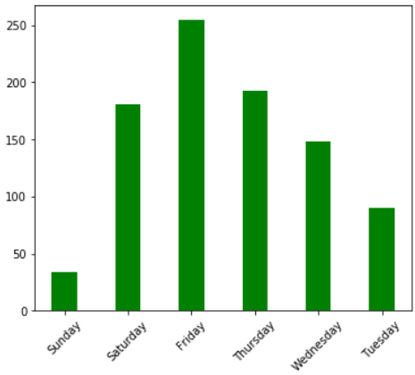
Tweets for Sunday were only gathered through roughly 1:00 am, so this does not reflect a full day of tweets. Aside from that, the number of tweets in the tag steadily increases as the week progresses, but starts to drop off on Saturday.

What is being said in the #DisabilityTwitter Tag?

What are the most commonly used words in the #DisabilityTwitter tweets?
 | word | abs_freq | wtd_freq | rel_value
0 | rt | 589 | 1937520 | 3290
1 | #disabilitytwitter | 487 | 1675519 | 3440
2 | disabled | 246 | 865147 | 3517
3 | people | 172 | 629717 | 3661
4 | disability | 132 | 616293 | 4669
5 | &amp | 73 | 279252 | 3825
6 | @esioul | 71 | 270040 | 3803
7 | 3 | 42 | 261322 | 6222
8 | #disability | 77 | 259465 | 3370
9 | including | 38 | 249295 | 6560
10 | like | 57 | 249200 | 4372
11 | help | 154 | 244522 | 1588
12 | #disabledtwitter | 38 | 244049 | 6422
13 | pandemic | 42 | 237565 | 5656
14 | principles | 35 | 232782 | 6651
15 | year’s | 34 | 232599 | 6841
16 | @forbes | 34 | 232599 | 6841
17 | holidays | 34 | 232599 | 6841
18 | #accessibility | 18 | 219660 | 12203
19 | great | 14 | 216629 | 15474
20 | need | 83 | 211839 | 2552
21 | @andrewpulrang | 33 | 198085 | 6003
22 | i'm | 85 | 197872 | 2328
23 | tweets | 7 | 188964 | 26995
24 | check | 13 | 186105 | 14316
25 | inclusion | 9 | 183606 | 20401
26 | start | 12 | 169766 | 14147
27 | checking | 3 | 167517 | 55839
28 | field | 3 | 167517 | 55839
29 | leaders | 3 | 167517 | 55839
30 | #a11y | 3 | 164208 | 54736
31 | #disabilityinclusion | 12 | 163672 | 13639
32 | community | 38 | 162348 | 4272

What is the frequency of terms commonly associated with disability discourse?
('inclusion') ('ADA') ('advocacy')
0.008 .002 . 0.002
('spoonie') ('accommodations') ('ableism')
0.013 0.017 . 028

The list of most commonly used terms include usual topics such as inclusion, community, accessibility, and ally as well as more issues related to current events such as pandemic and forbes (in response to a recent article.

A sentiment analysis of the text of all of the tweets in the dataset labeled all the tweets together as having an overall “positive” tone. While the overall sentiment analysis returned a positive tone, it is interesting when the tweet content is viewed in the form of a word cloud. Words such as “upset,” “rejected”, and “pandemic” are what stand out strongly. Terms such as “Sia” also reflect discussions around recent controversy.

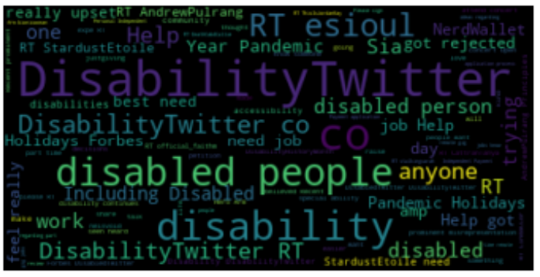

Overall this analysis shows that there is a large community utilizing this tag. It is not dominated by high profile accounts or even by those with large follower accounts. Users tend to use either laptop browser or traditional smartphone app when they create tweets are retweet others’ tweets, and activity shows an increase as the week progresses, dropping off with the weekend.
Words used in these tweets show that tweets made in this tag vary from specific and personal struggles to general struggles faced by most of the disabled community, as well current events and media and how they pertain to and affect disabled individuals and the disabled community. In addition to being a tool of discourse, it is also a tool of support, whether it is for emotional support or practical support in terms of job seeking or obtaining needed funds.

